Exporting/Importing Chrome Bookmarks
Exporting:
- First open up Chrome and click on the 3 dots on the upper right hand corner of the browser. The hover over Bookmarks and a new menu should appear. In this new menu select Bookmark Manager.
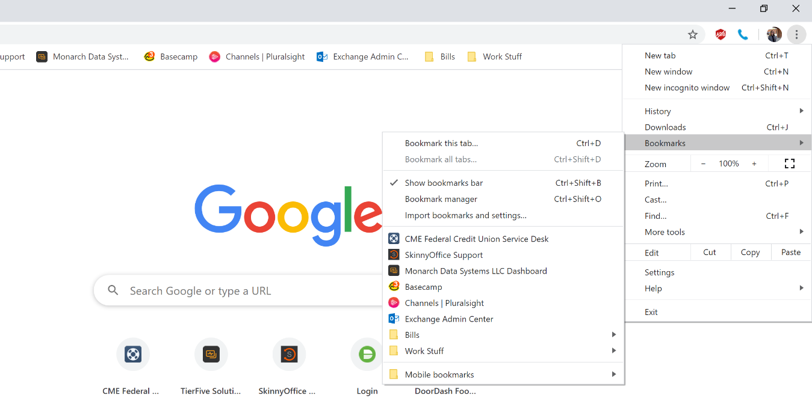
- This should open up a new tab that has all of your bookmarks. On this page select the 3 dots at the end of the blue bar going across the screen. Another menu should appear, select Export Bookmarks.
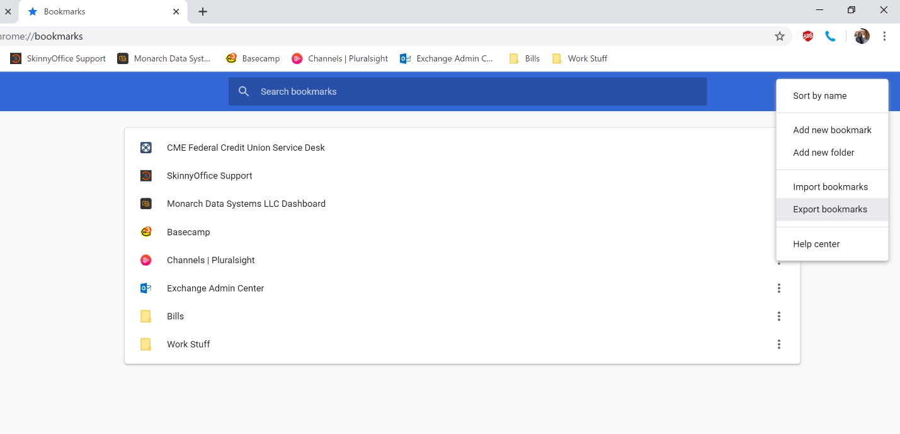

- A File Explorer window will pop up and ask where you would like to save the exported bookmarks. I recommend saving them to the desktop for easy access.
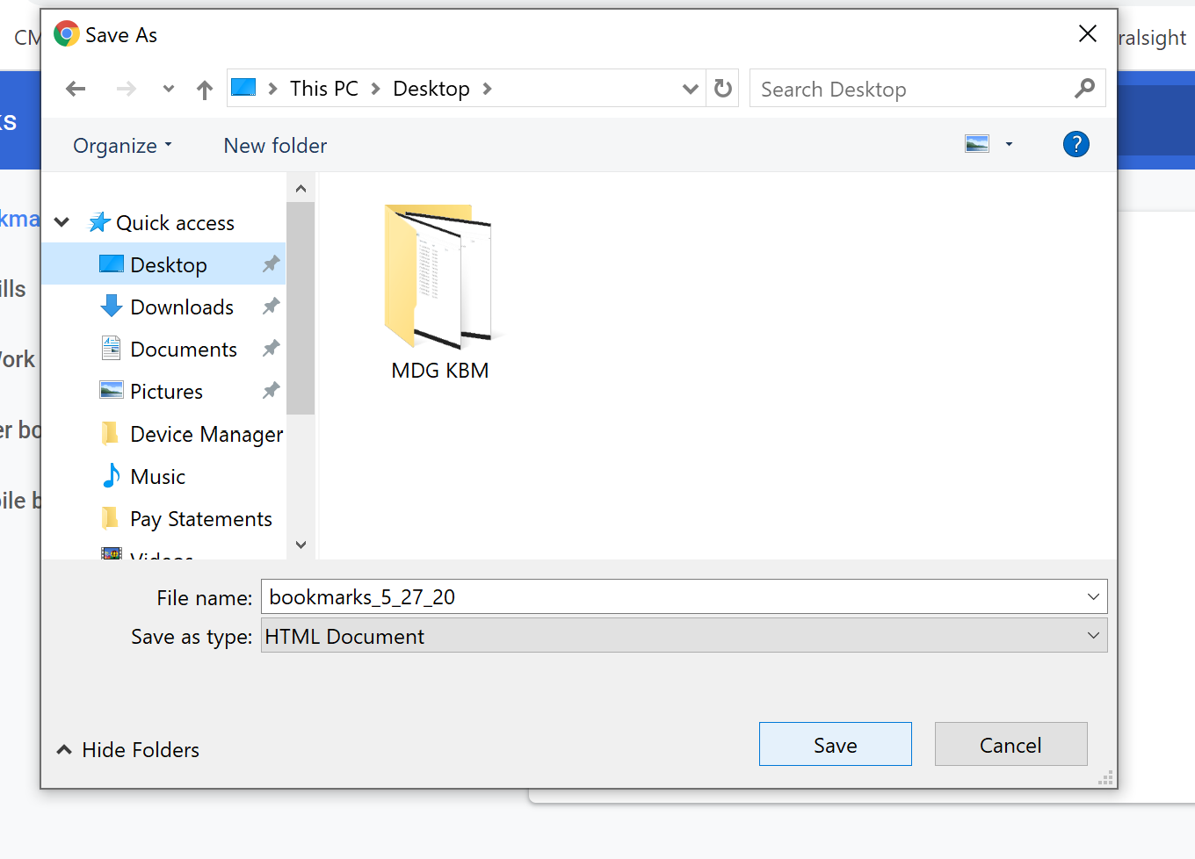
- You will then see a new file on the desktop that should look similar to this just with a different date:
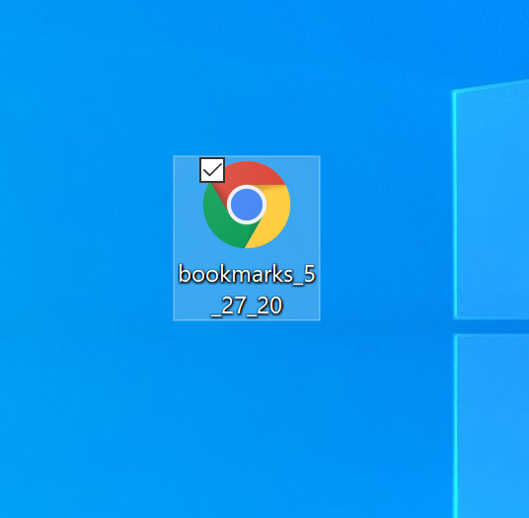
- If you are attempting to get your Chrome Bookmarks into your WorkSpace please follow the steps in the Knowledge Base Article: Copying Files into WorkSpace.

Importing:
- First open up Chrome and click on the 3 dots on the upper right hand corner of the browser. The hover over Bookmarks and a new menu should appear. In this new menu select Bookmark Manager.
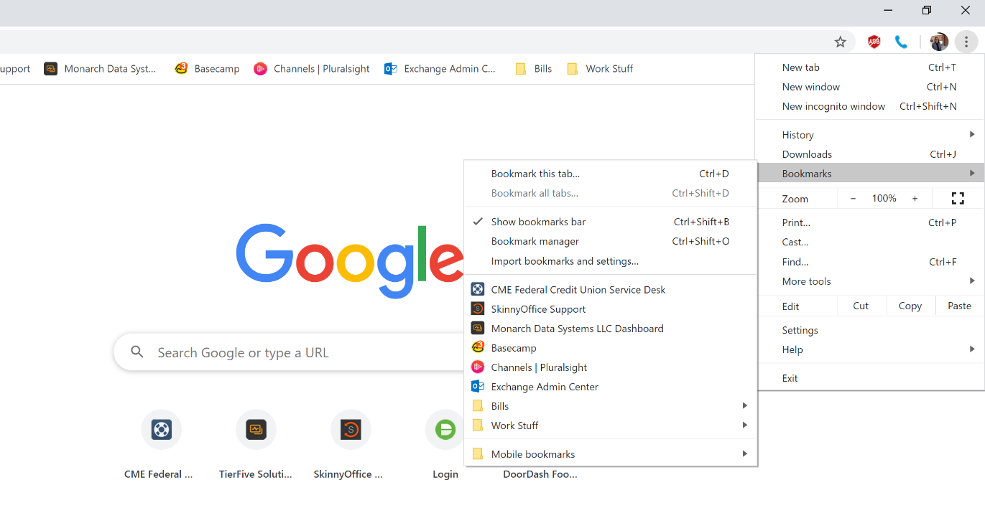
- This should open up a new tab. On this page select the 3 dots at the end of the blue bar going across the screen. Another menu should appear, select Import Bookmarks.
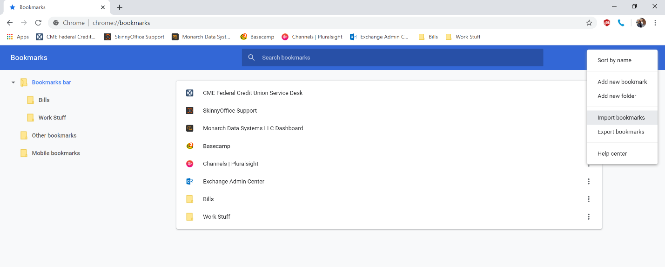

- A File Explorer window will pop up and ask where you would like to import your bookmarks from. Select the bookmark file that you have saved to the PC and press Open.
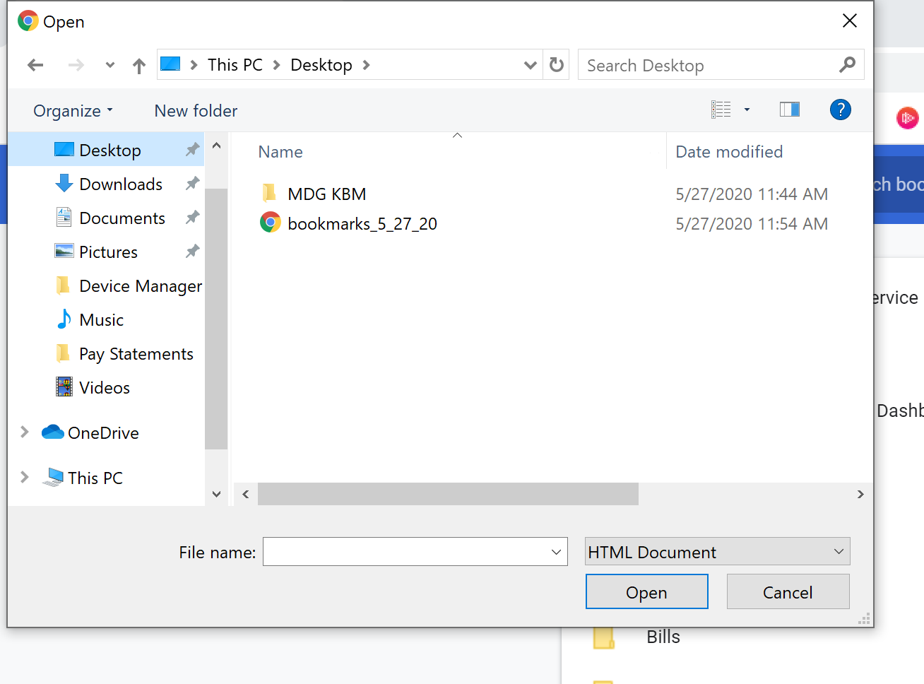
- This should import all of you Chrome bookmarks into your current Chrome browser.

