Copying Files into WorkSpace
- After logging into WorkSpace open up File Explorer:
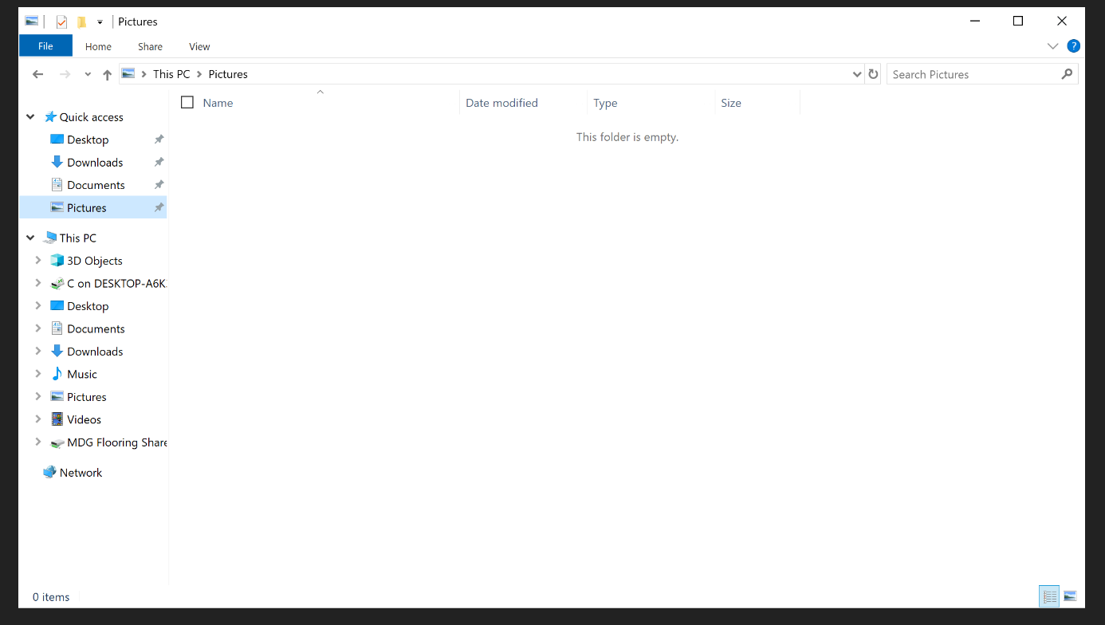
- Under “This PC” you should see a section that says “C on (whatever your PC name may be)”. This is where all the files on your physical PC will be. Through there you will select the “User” folder then your personal folder on the PC. Under there will be all of your pictures, documents, etc…
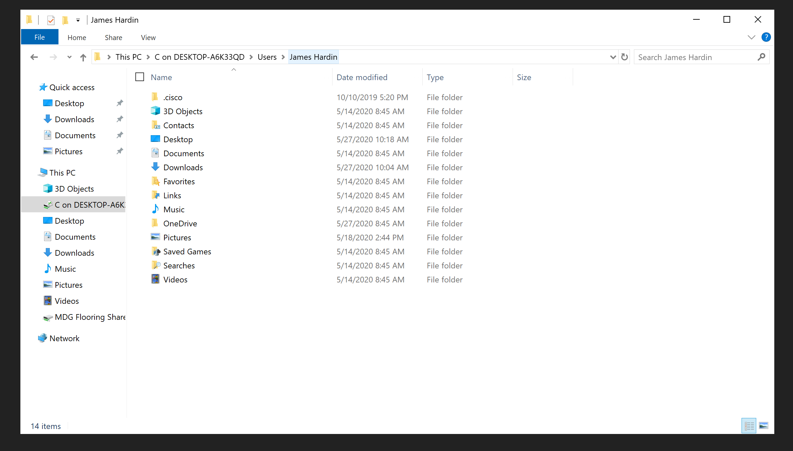
- From there you can select either a single file or an entire folder, Right-Click on it and select copy. Then under “This PC” on the Left Hand panel you can choose which place you would like to copy the folder, Documents, Desktop, Pictures, etc... Select where you would like to copy your file, Right Click in the empty space and select Paste.
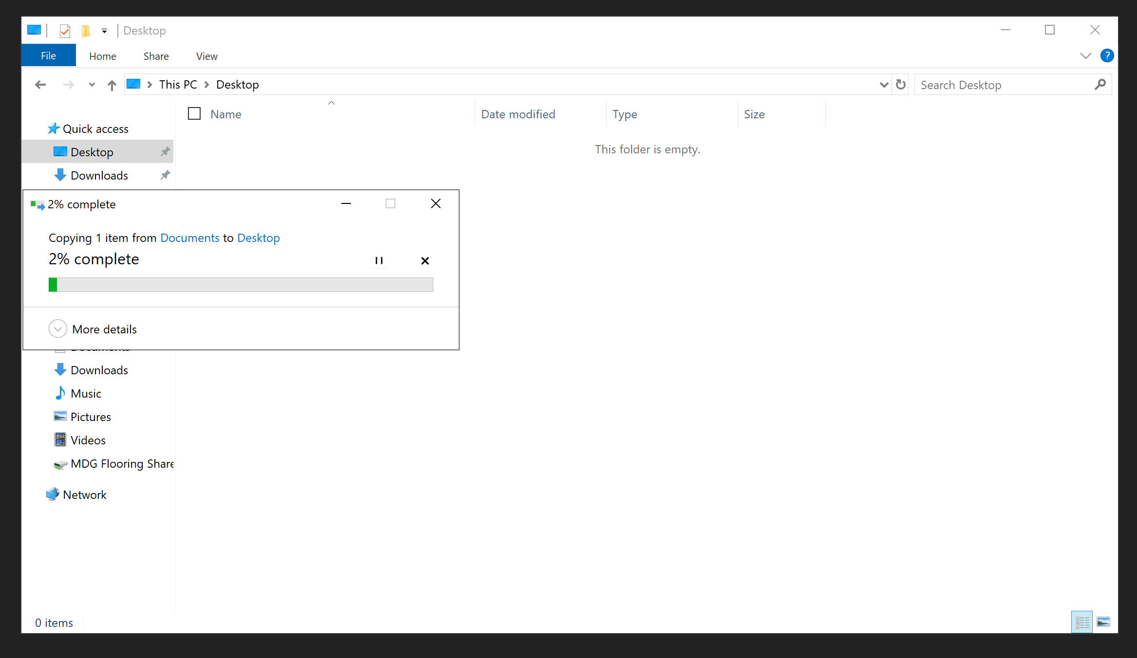
- It should then start copying the files over to your WorkSpace. The time this takes will vary depending on how much is being copied over.

