Resetting WiFi Driver

- Open up Device Manager by Right-Clicking on the Windows Start menu and Selecting Device Manager from the menu that appears.

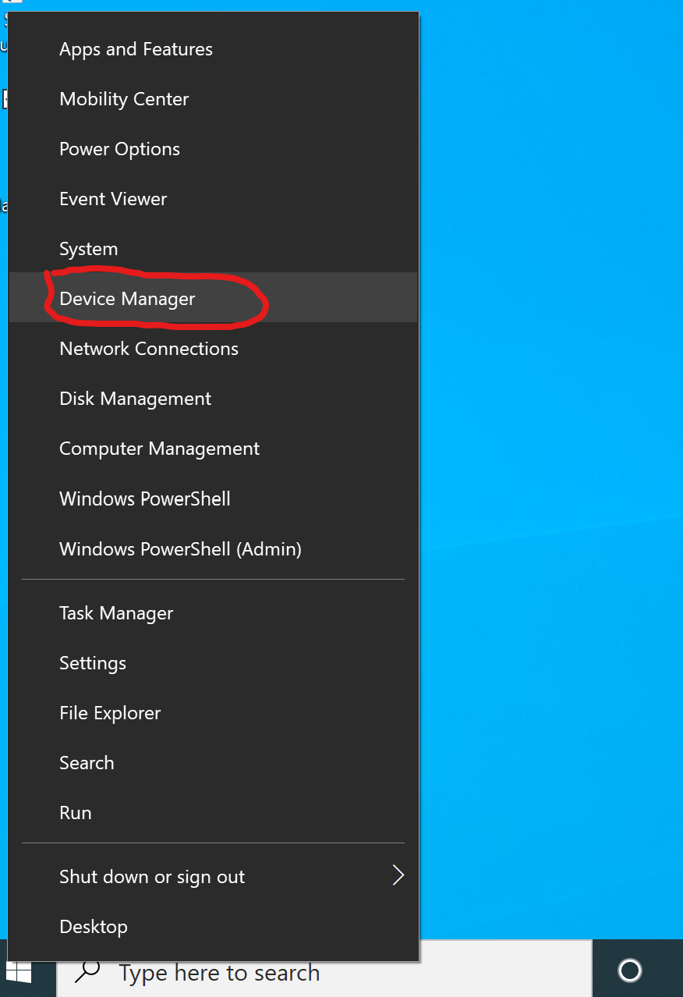

- Once in Device Manager search for the drop down labelled Network Devices. Under this drop down will be your WiFi Driver. It will most likely have a different name then what is listed in the photo, but it will be something along the lines of Wireless adapter.
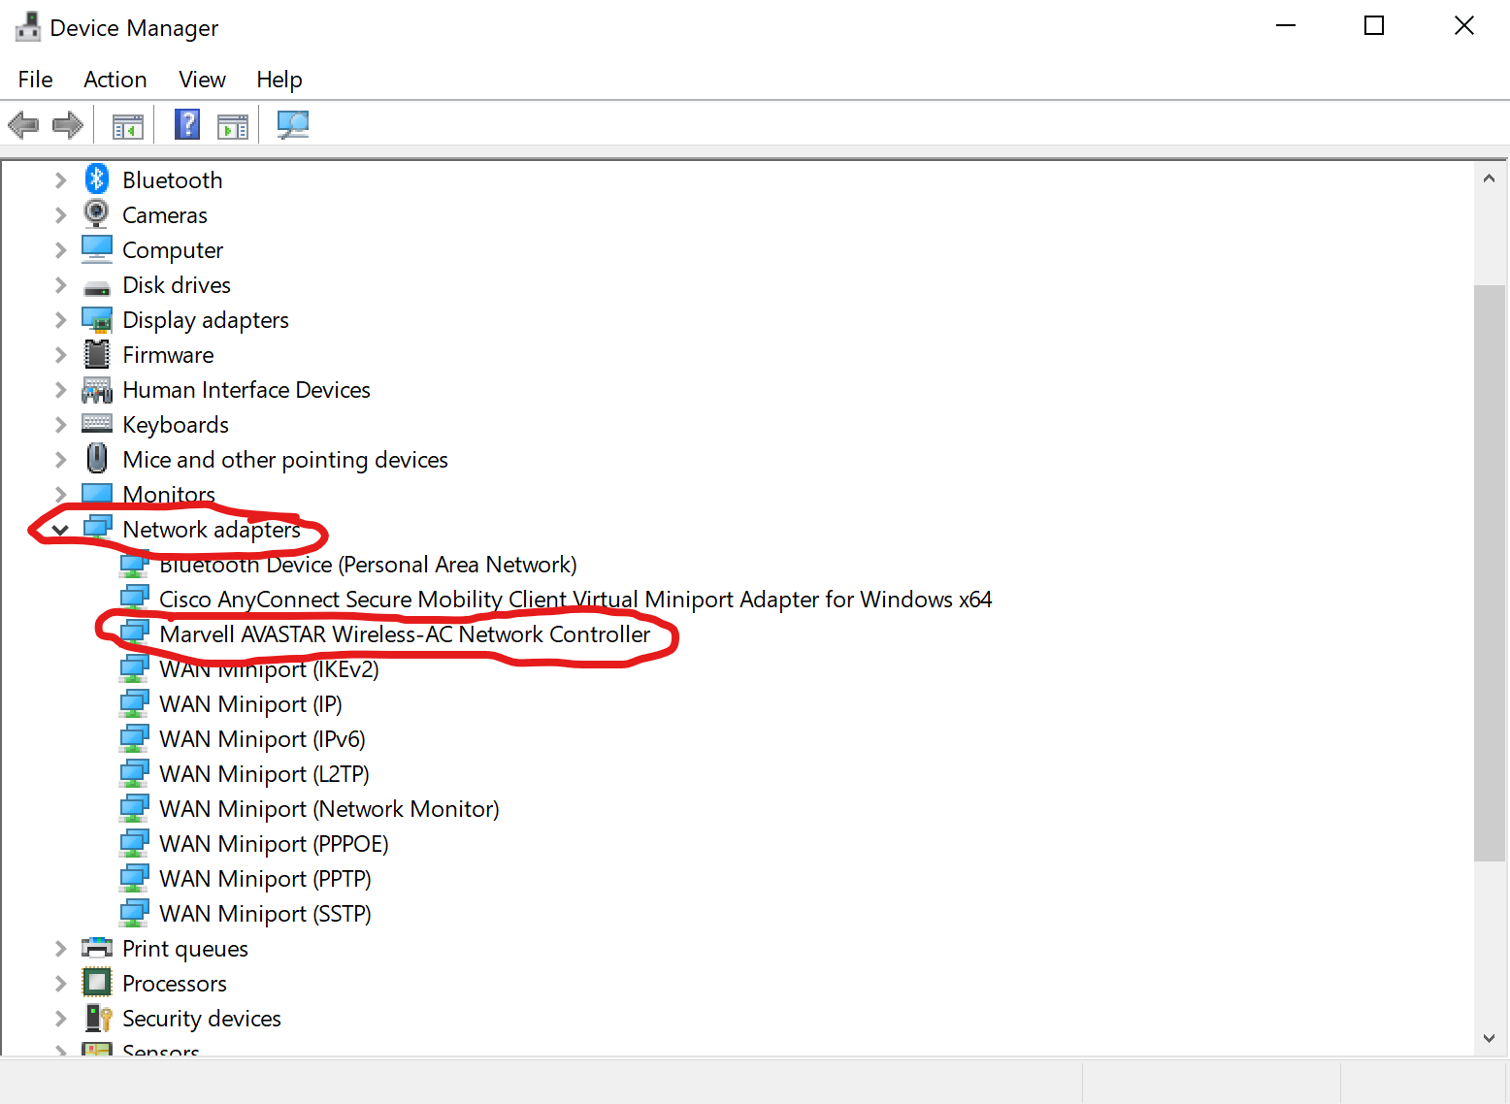
- Next, Right-Click on your WiFi Driver and Select uninstall.

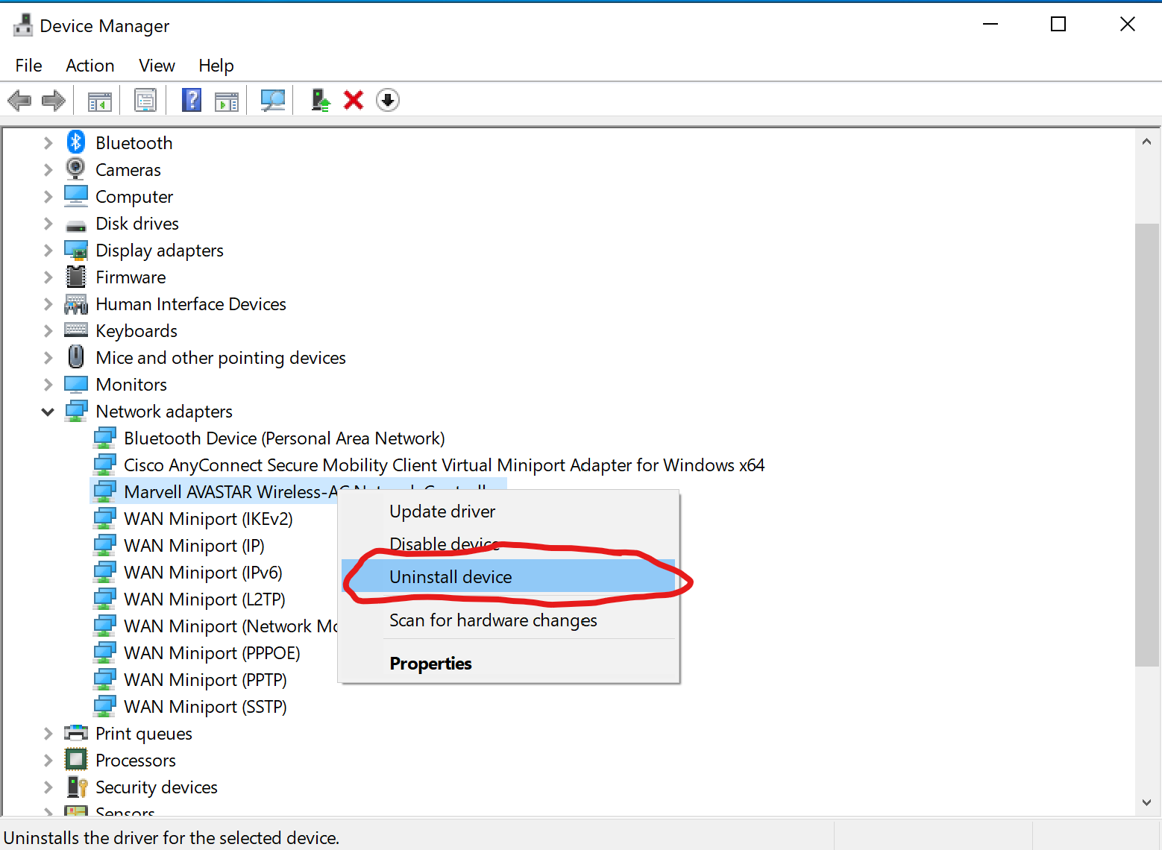

- After uninstalling the Driver go ahead and perform a restart on the PC. After the PC boots back up open your WiFi and attempt to reconnect to your network.

